

Site A demolition update: Edition 6
This email provides a brief overview of what happened in the previous week and what you can expect to happen next week.
If you have any questions about the demolition programme, you can contact Adrian Buch, the Project Manager, by using the following:
Adrian.Buch@keltbray.com
Mobile - 07902 437 389
------------------------------------------------------------------------------------------------------------------------
Works over the last two weeks
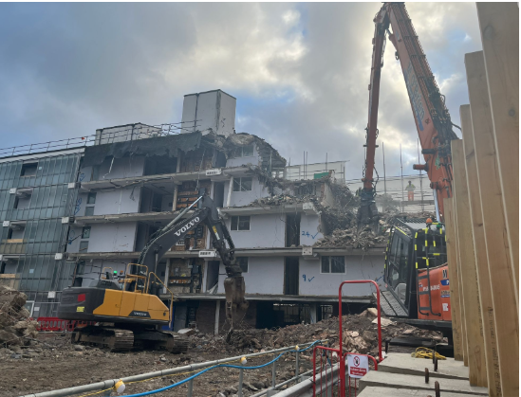
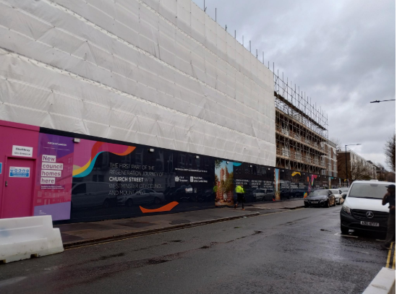
* Soft strip (internal demolition of partition walls, plasterboard, furniture etc) Lambourne House - completed Sunday 15th December
* Demolition of Lambourne House with muncher/ High reach with munching attachment – commenced 16/12/25 – completion of demo to ground floor slab planned for mid-February
* Graphics on Broadley Street Hoarding Installed W/C 16/12
------------------------------------------------------------------------------------------------------------------------
New Year Woks
Hoarding install on Penfold Street - W/C 06/01 to 13/01
Soft strip Pool House - W/C 13/01
------------------------------------------------------------------------------------------------------------------------
Christmas Shutdown
Demolition will finish on Friday 20th December and resume on Monday 6th January. The Site will have 24-hour security. If you have any concerns, you can call 07436 149 067 24 hours.
------------------------------------------------------------------------------------------------------------------------
Keltbray and the council will monitor the impact of this route throughout demolition and, based on the results of this monitoring and resident feedback, will examine how we can further improve its operation.
------------------------------------------------------------------------------------------------------------------------
FIND OUT MORE
You can keep track of the latest news on the Church Street website at churchstreet.org (https://churchstreet.org/) . Please email us at churchstreet@westminster.gov.uk
You are getting this email as you have signed up for email updates on the demolition of Site A. If you don't want to receive these emails, please email churchstreet@westminster.gov.uk to let us know.
https://www.facebook.com/mychurchstreet



