

Site A demolition update: Edition 7
This email provides a brief overview of what happened in the previous week and what you can expect to happen in the coming weeks.
If you have any questions about the demolition programme, you can contact Adrian Buch, the Project Manager by using the following:
Email: Adrian.Buch@keltbray.com
Call: 07902 437 389
------------------------------------------------------------------------------------------------------------------------
Demolition update for January
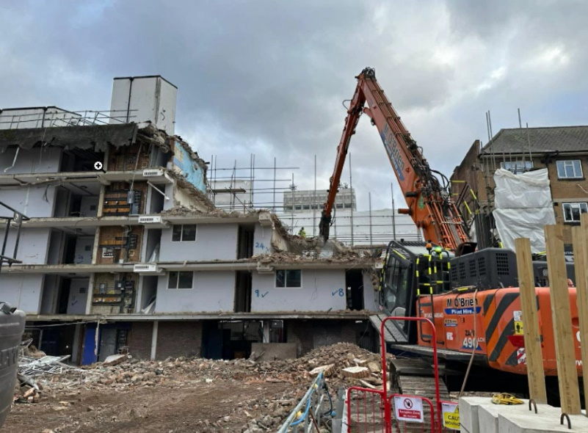
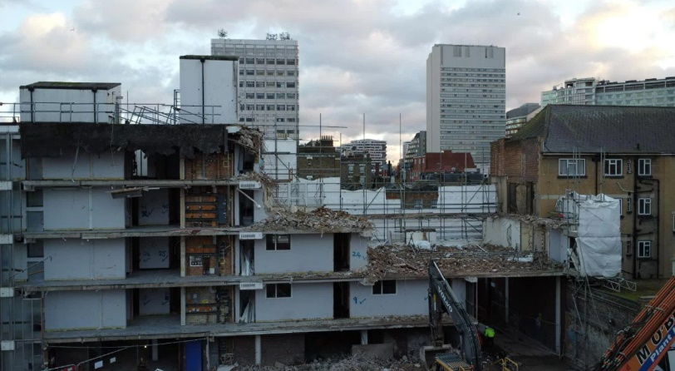
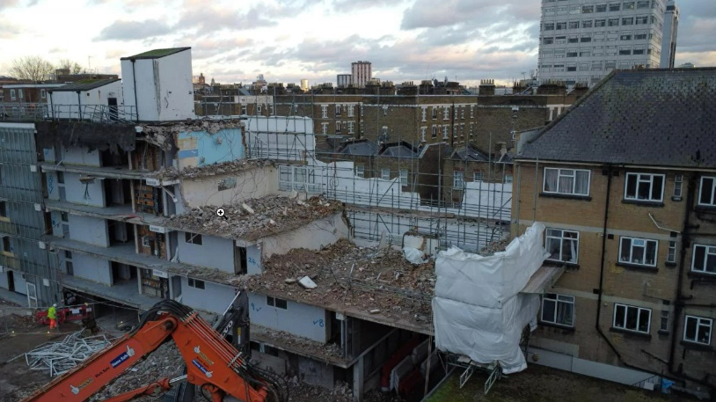
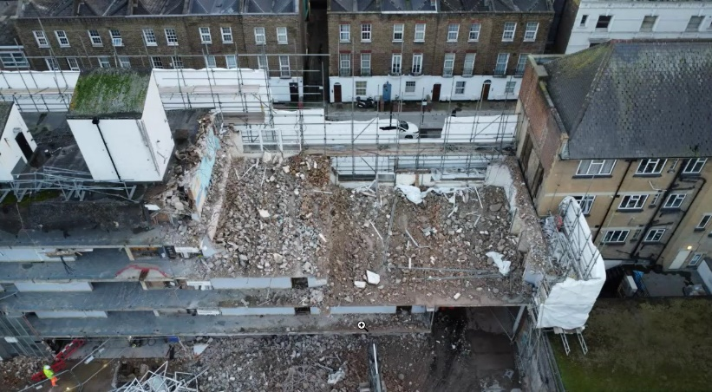

* Demolition of Lambourne house will continue until 30 January.
* Hoarding installation will start on Penfold Street during the week beginning 6 January and will continue across that week.
* Removal of internal fixtures and fittings in Pool House will start during the week beginning 13 January.
------------------------------------------------------------------------------------------------------------------------

Keltbray and the council will monitor the impact of this route throughout demolition and, based on the results of this monitoring and resident feedback, will examine how we can further improve its operation.
------------------------------------------------------------------------------------------------------------------------
FIND OUT MORE
You can keep track of the latest news on the Church Street website at churchstreet.org (https://churchstreet.org/) . Please email us at churchstreet@westminster.gov.uk
You are getting this email as you have signed up for email updates on the demolition of Site A. If you don't want to receive these emails, please email churchstreet@westminster.gov.uk to let us know.
https://www.facebook.com/mychurchstreet



