
------------------------------------------------------------

Talking to Local Residents About the Demolition Process

With the serious demolition work about to start, Keltbray, Mount Anvil and our engagement team have been busy ensuring local people are aware of what to expect. So far, we’ve spoken to residents at:

•Coffee Mornings at Local Schools: Christ Church Bentick, King Solomon Academy and Gateway Academy

• Residents who attend the Penfold Centre’s Bingo afternoon

• The annual Antiques Market

• Church Street Community Market

• Drop-in sessions for Businesses and Market Traders

We spoke about how and when demolition works will happen, traffic management plans and what our team is doing to monitor and minimise impact on our residents. In the next week expect to see the arrival of the high reach machine that will begin the demolition of Ingrebourne House. This will be a momentous moment in the regeneration project!

Site Working Hours

* Monday - Friday, 8.00am to 6.00pm
* Saturdays (for essential works only) 8.00am to 1.00pm
* No works on Sunday
------------------------------------------------------------
Site A Will Bring

*430 new homes, at least 50% of which will be affordable
* New Church Street Library
* Improved public spaces
------------------------------------------------------------
Keltbray creating Job Opportunities for Local People
Harvel, a local resident, has been employed by Keltbray as a Demolition Labourer following attendance at the Westminster Employability Day that took place at Greenside Community Centre on 13 September. You can read more about how Harvel is getting on in the October Church Street Newsletter.
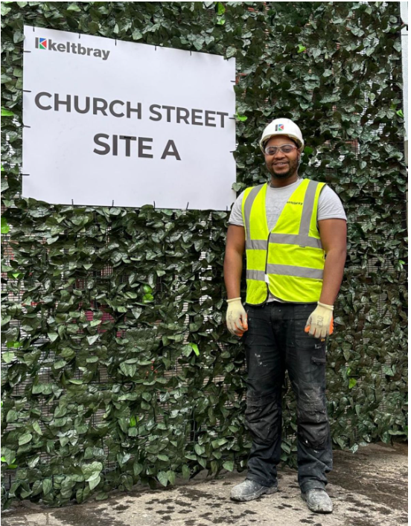

------------------------------------------------------------
Traffic Management

Keltbray and the council are monitoring the impact of this route throughout demolition and based on the results of this monitoring and resident feedback, will examine how we can further improve the operation.
------------------------------------------------------------
Demolition Update

What’s Happened

Week 1 -23 to 27 September

• Site up offices and facilities for staff based on site – this is known as ‘site mobilisation’

• Temporary Services and water / electric supplies have been set up at the site

Week 2 - 30 September to 4 October

• Installation of hoarding on Broadley Street

• The removal of internal fixtures and fittings inside

Week 3 - 14 to 18 October

• Gate installation on Broadley Street

• Soft strip works to Ingerbourne House and Lambourne House

Week 4 - 28 October to 1 November

• Scaffolding will be erected along Broadley Street

• First building knocked down

Week 6 - 18 to 22 November

• 18 November saw the arrival of the High Reach machine. This is the machine that will demolish the building
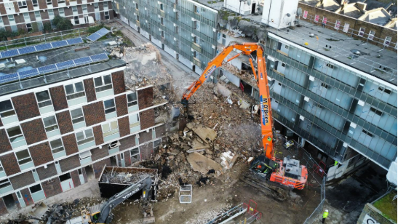
------------------------------------------------------------
FIND OUT MORE
You can keep track of the latest news on the Church Street website at churchstreet.org (https://churchstreet.org/) . Please email us at churchstreet@westminster.gov.uk (mailto:churchstreet@westminster.gov.uk?subject=Contact%20from%20website)
IF YOU HAVE A QUESTION Visit us Monday to Friday 9am to 5pm at 56 Church Street, NW8 8ET. Call us at 020 761 2968
------------------------------------------------------------
You are getting this email as you have signed up for email updates on the demolition of Site A. If you don't want to receive these emails, please email churchstreet@westminster.gov.uk (mailto:churchstreet@westminster.gov.uk?subject=Contact%20from%20website) to let us know.
https://www.facebook.com/mychurchstreet



