

Traders relocation

**Information for market traders**

October 2021

22

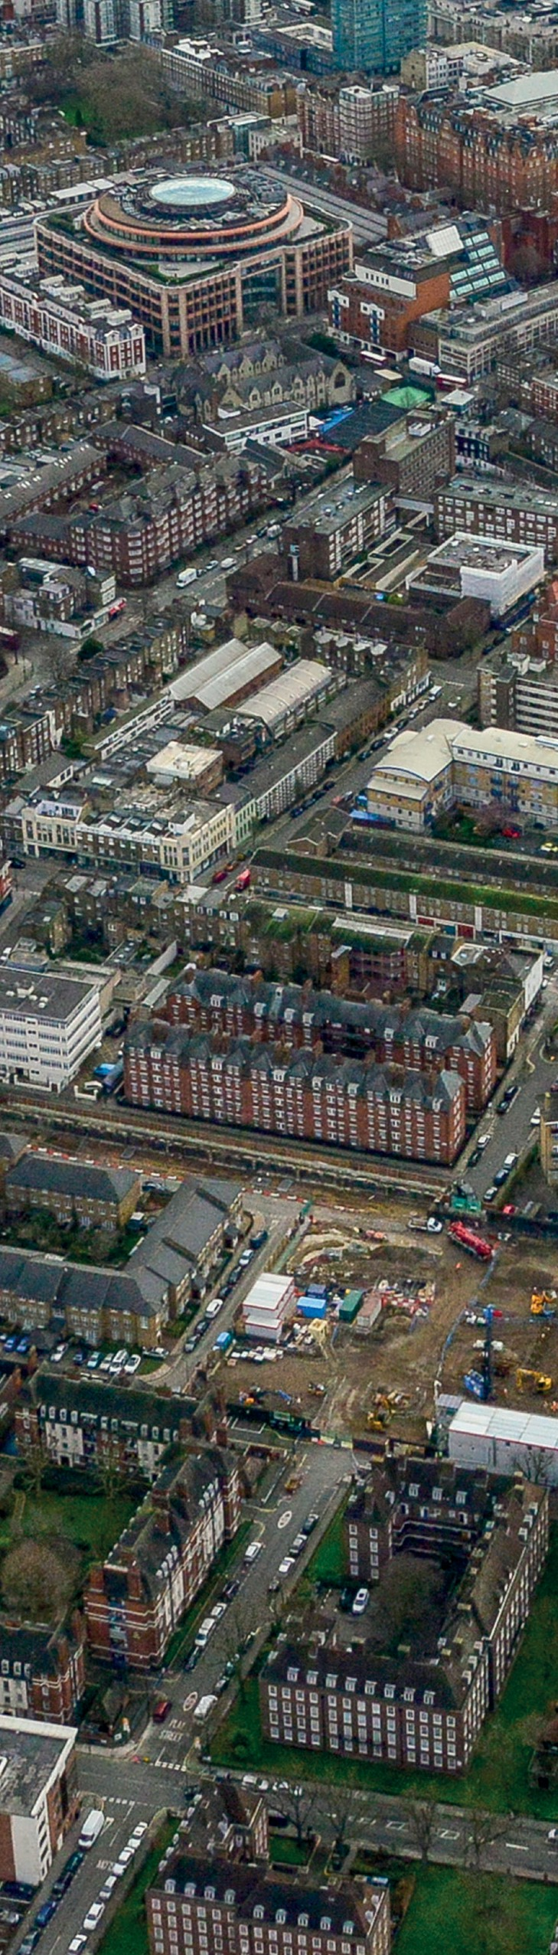

|  |  |  |
| --- | --- | --- |
| Church Street is Westminster City Council’s largest regeneration scheme and will see the redevelopment of Sites A, B and C which includes ground floor commercial units and the public area. It will create a new street layout from Lisson Grove to Edgware Road as well as providing new storage space, parking facilities, access to on-street electricity and water supplies and toilets specifically for market traders.  This pamphlet outlines how we plan to minimise disruption of building work and the impacts of both the Site A and public area works on the market. Our approach will enable stallholders to continue trading for as long as possible. Trading suspensions will only be in place for Saturday traders that are directly affected by the works. Saturday traders  will remain on current pitches during Site A works, but will have pitches suspended when affected by public area works.  We expect works to Site A and the public area to start in winter  2022/2023. These are indicative dates for the works and we will keep you informed as the project progresses. | | |
| 2 |  |  |

3

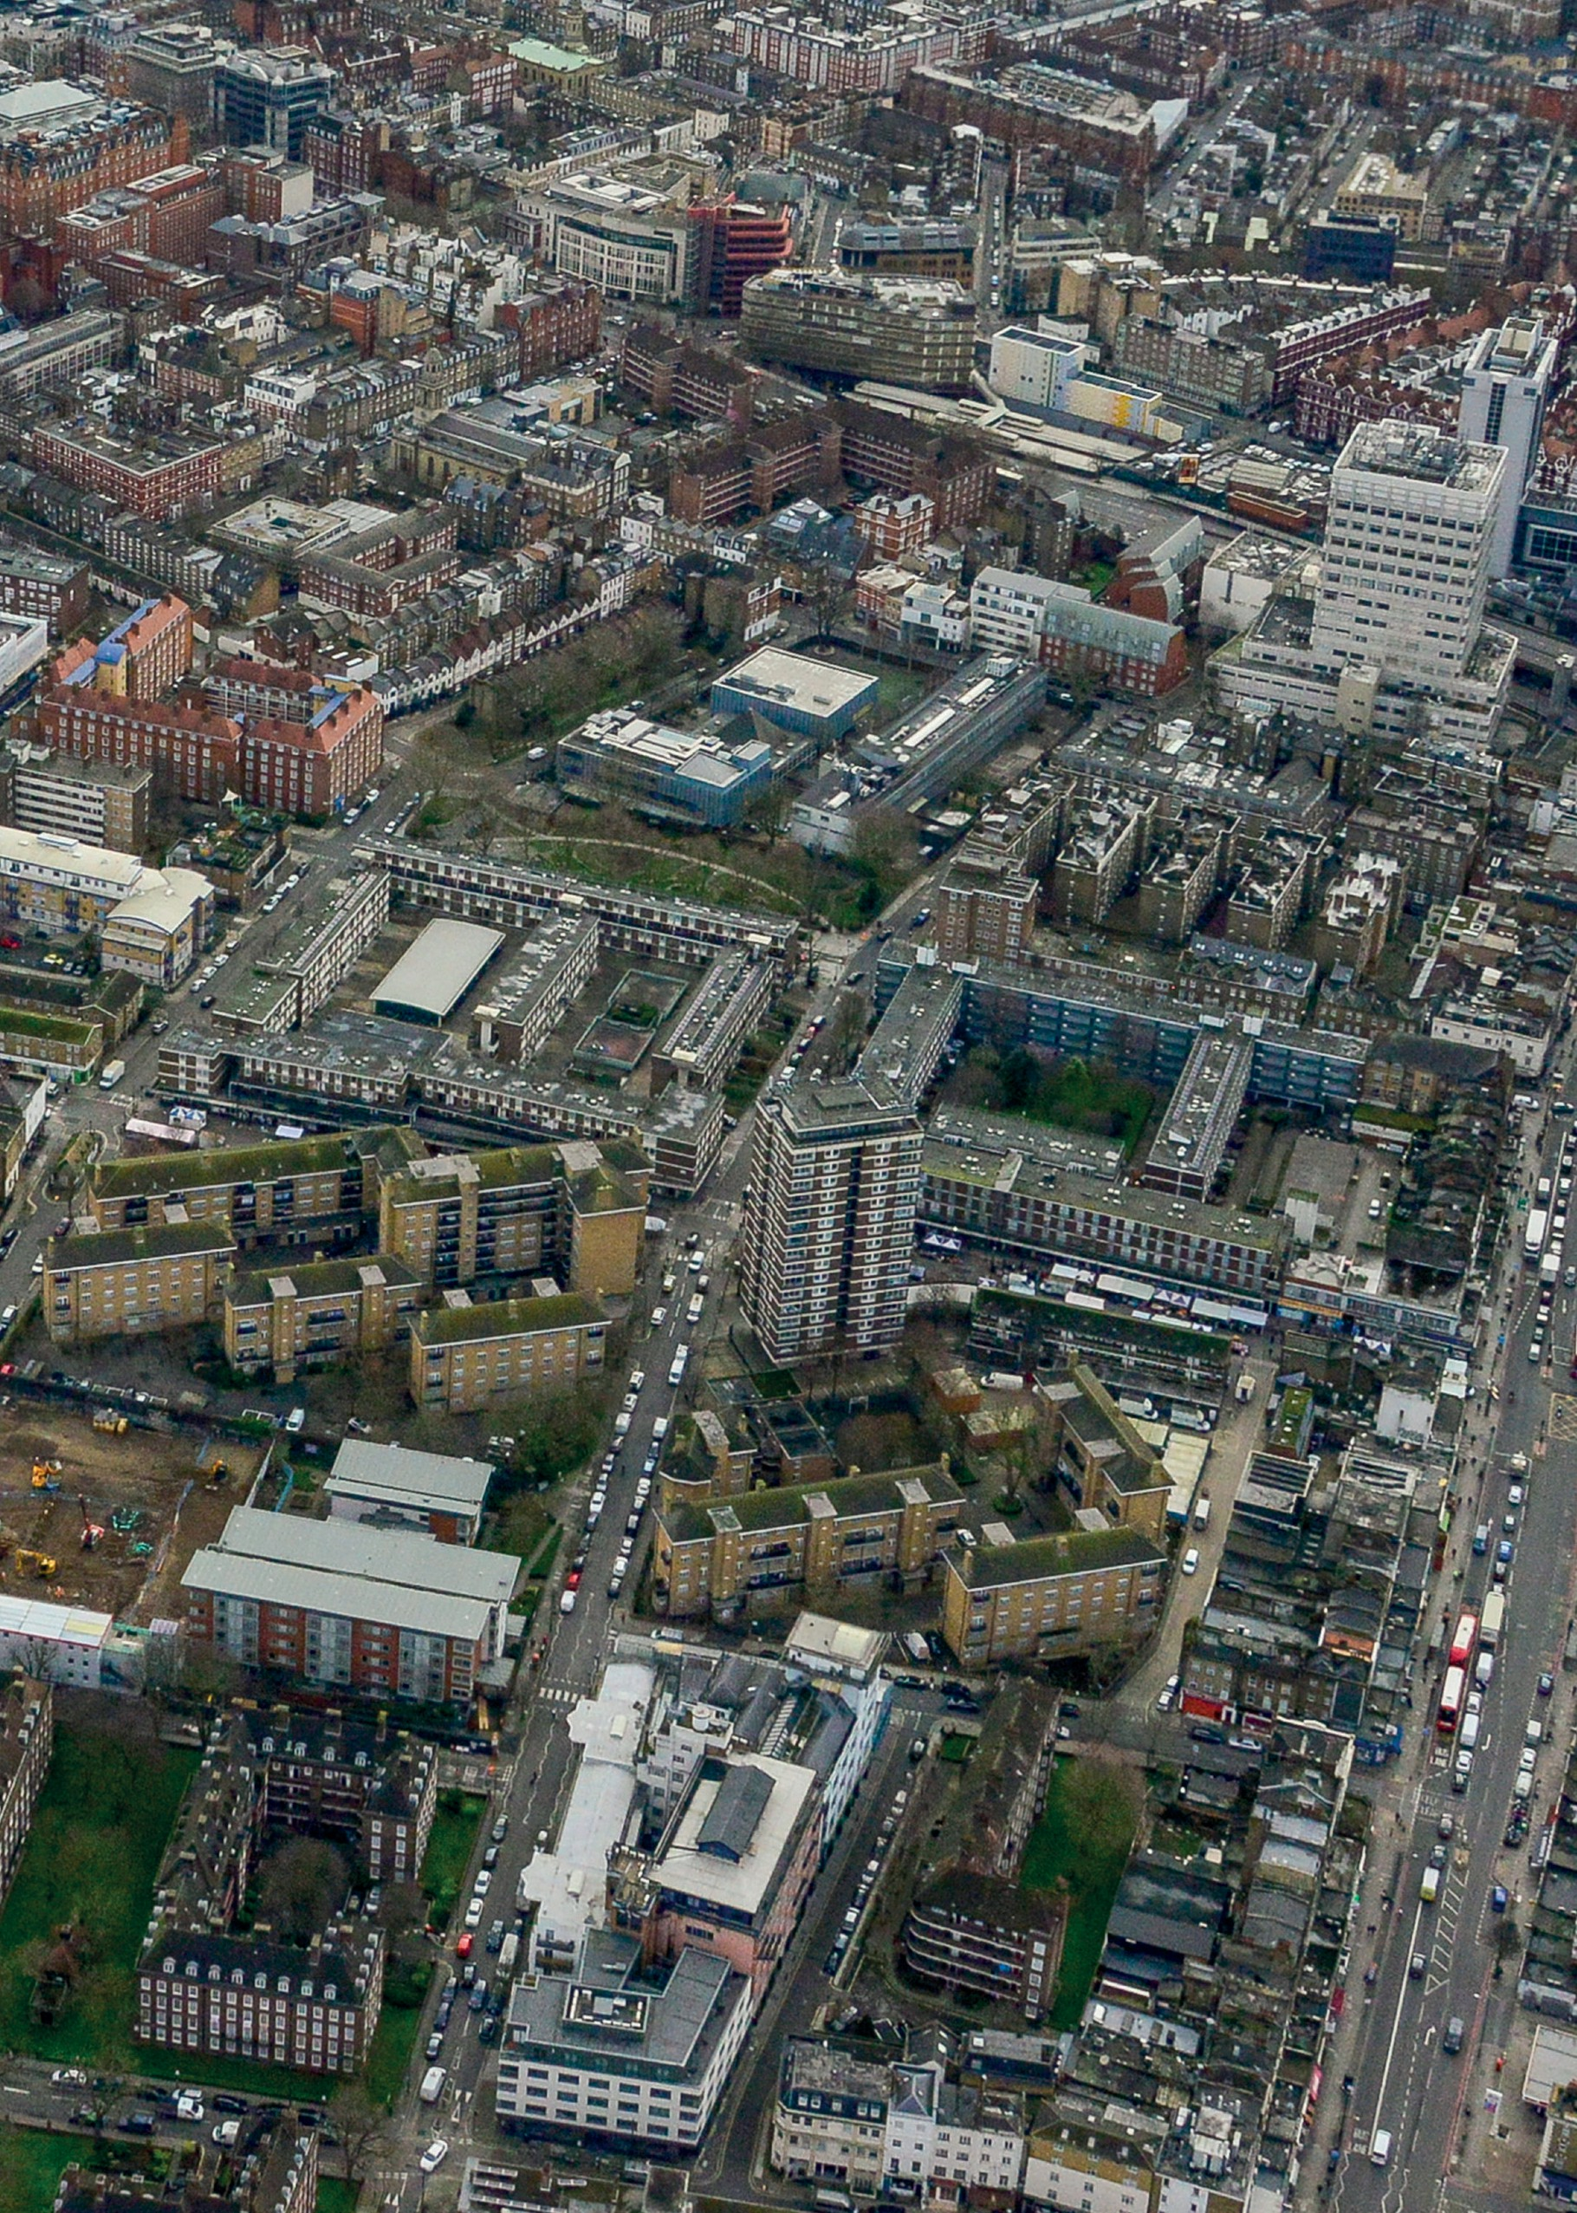

B

A

C

Location map of Sites A, B and C at Church Street

4

**The following outlines our approach to the two different types of works for weekday and Saturday traders:**

# Site A works

Site A works involve the complete demolition and rebuild of Site A.

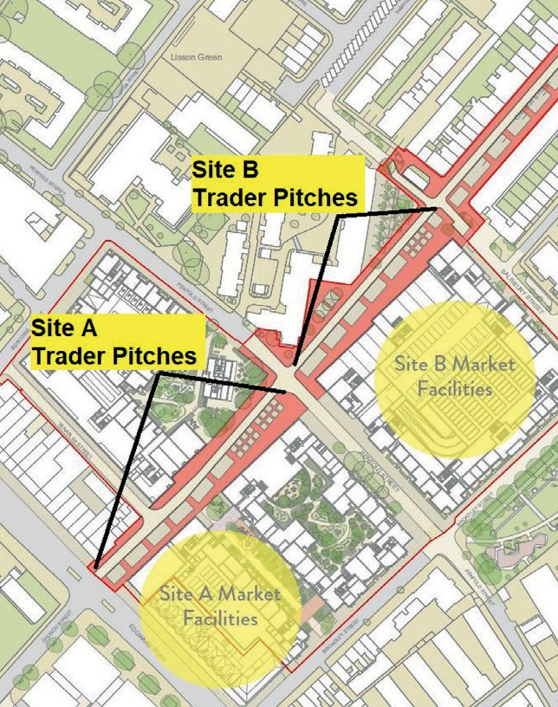

Site A Trader Pitches

Site B Trader Pitches

**Monday – Friday traders** will remain on their pitches whilst Site A works take place.

If short term or long term relocation is required as a result of heavy works or heavy plant delivery, traders can be moved to Site B pitches or to the north kerb of Site A as an alternative, temporary location to trade from.

**Saturday traders** will remain on their current pitches starting from Edgware Road.

As noisy works are prohibited from taking place on a Saturday, there should be reduced disruption to traders in this area on this day.



**The market street layout**

Planting bed

Footway

Carriageway

4

5

# Public area works

The public area work will be delivered separately to the Site A works and will involve replacing and redesigning the existing pavement and road. This will result in new pitch locations toward the centre of the street in a back to back format (there will be space between the back of food stalls only).

Due to the disruptive nature of these works, affected pitches will need to be suspended. The works will be phased in small increments so the impact on individual traders is reduced to a minimum.

**Monday – Friday traders** can be relocated to Site B (Penfold Street to Salisbury Street) in small groups as the phased work is undertaken.

**Saturday traders** will continue to trade as usual until the phased works commence. Traders occupying pitches marked for works will not be able to trade from those locations.

Traders can return to their new pitches when they become available. We plan to phase works in small stages to reduce the impact on traders.



Market stall

Market stall

Footway

5

# Market traders returning to new pitches

When the new pitches do become available, they will be located toward the middle of the street.

The sequencing and numbering of the pitches will remain the same and as such we do not expect a change to the

positioning of traders. Traders will retain their existing licences and therefore return to the same area of the street.

# Relocation process

Should traders need to be relocated, we will give as much advance notice as possible.

Weekday traders will have allocated temporary pitches to move to if necessary.

We will share these pitch numbers with the traders in advance.

Market Inspectors will also have sight of the alternative layout to assist with relocation.

Our licensing team have confirmed that any traders unable to operate due to the pitch suspensions will have their pitch fees waived for that period.



This is our current approach to reduce the impact on traders and their ability to trade.

However, this approach may change as plans progress further, but we will keep you informed every step of the way.

Be assured, our priority is to ensure that we can keep stalls operating with as little disruption as possible.

If you have any questions or want to discuss further, please contact Devrim Zarif:

By calling 07890 380 252

By emailing [churchstreet@westminster.gov.uk](mailto:churchstreet@westminster.gov.uk)

6

# Church Street Market Pitches

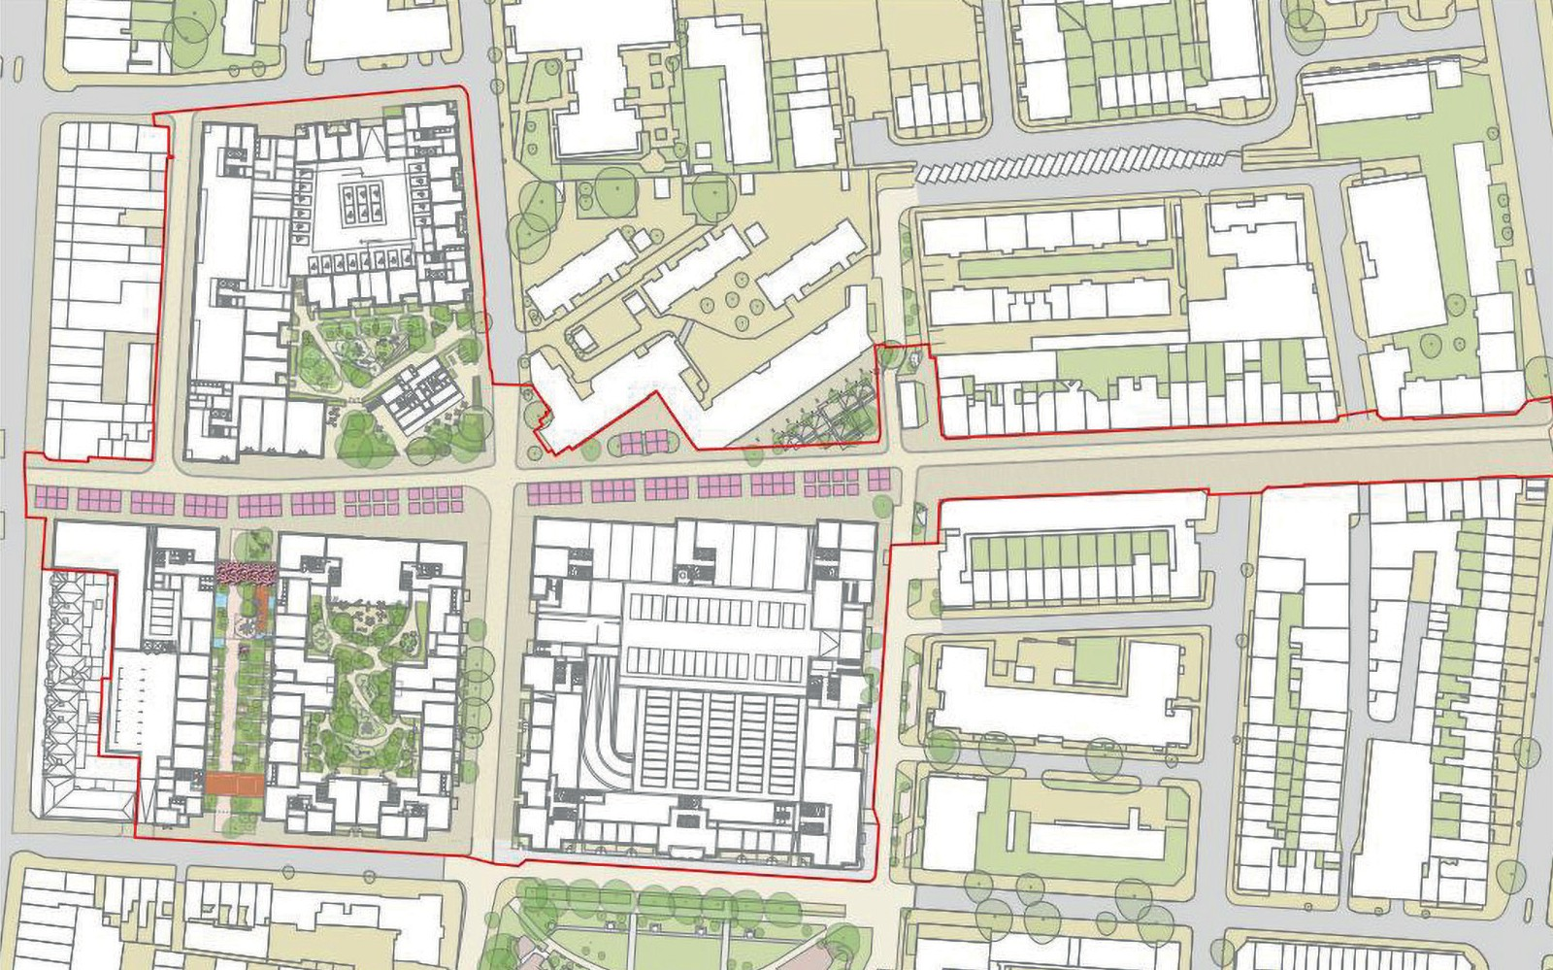

**Church Street Market**

132 pitches Monday – Wednesday 135 pitches Thursday – Friday

Monday – Friday, 8am – 6pm

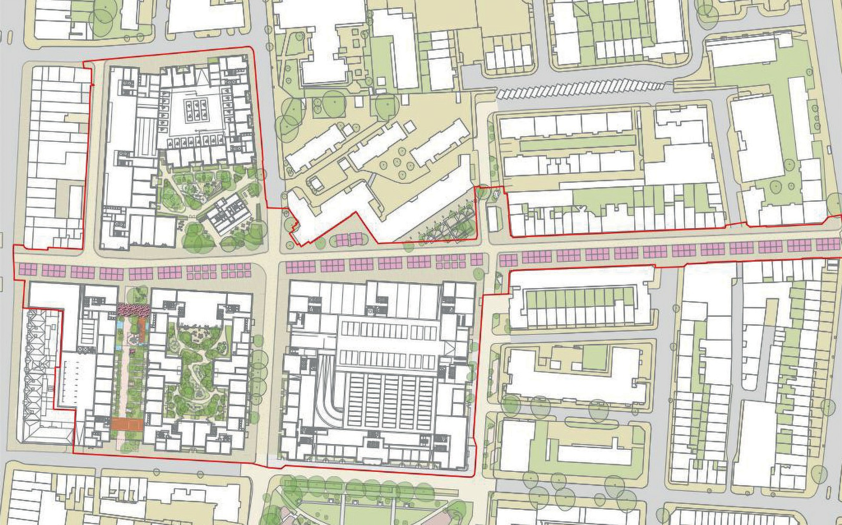

**Church Street Market**

220 pitches

Saturday, 8am – 6pm

7



# For more information

Visit our website at **churchstreet.org**

Call us on **020 7641 2968**

Email us at [**churchstreet@westminster.gov.uk**](mailto:churchstreet@westminster.gov.uk)

If you need help understanding this information, we can arrange for a translation. Please call us on **020 7641 2968.**

. 02076412968

আপনার যদি এই তথ্যটি বRাঝার জনয সাহায্যযর প্রয্ াজন হ তয্R আমরা একটি ট্রান্সয্েশন RযRস্থা করয্ত পাদর। Rা আমায্ির কে করুন 0২0৭৬৪১২৯৬৮